2.1.Dot matrix infared camera
1.
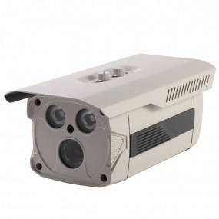
Sony Array IR Weatherproof Camera
BA-8070L
Main features:
Array IR Weatherproof Camera with 4mm Board Lens 2pcs* Array IR-LED
Feature: IR Range: 45M
2pcs* Array IR-LED
Camera Solution: SONY ICX673AK + Effio-E(4140)
Resolution: Color 1/3" SONY 960H CCD 720TVL, OSD, DWDR, 2DNR
Perfect Night Vision
Built-In 4mm Board Lens
(6mm is optional)
OSD menu optional
Water Resistant Rate: IP66 Weight: 1.1Kg

Model | BA-8065L |  | BA-8070L | BA-W8096L
Sensor + DSP | SONY ICX811AK  + Effio-E (4140) |  | SONY ICX673AK  + Effio-E(4140) | SONY ICX663AK  + Effio-V (4141)
Pixel | PAL:976(H)*582(v)  NTSC:976(H)*492(v) |  | PAL:976(H)*582(v)  NTSC:976(H)*492(v) | PAL:976(H)*582(v)  NTSC:976(H)*492(v)
TV Lines | 7OOTVL |  | 720TVL | 720TVL
Signal System | PAL/NTSC
Lens Optional | 4mm,6mm Lens optional
Minimum Illumination | 0 Lux (Infrared on)
S/N | >52dB
Shutter speed | 1/50(1/60)_1/100,000(Sec.)
Gamma Correction | > 0.45
Synchronous mode | internal synchronization
White Balance | Auto white balance
Video Output | 1Vp-p,75ohm,BNC
Power | DC12V,1000mA
Infrared wavelength | 850nm
Infrared distance | 45M
Infrared Led | 2pcs* Array IR-LED
weight | 1.1Kg
Temperature | (-20°C ~ +50)
Water resistance | IP66

2.
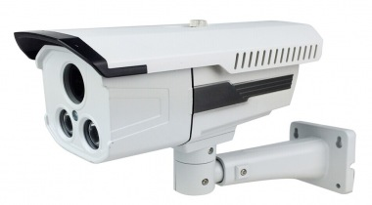
Security CCTV Array IR Weatherproof Camera
BA-802M
Main features:
Array IR Weatherproof Camera with 4mm Board Lens 2pcs* Array IR-LED
Feature: IR Range: 40-50M
2pcs* Array IR-LED
Camera Solution: CMOS PC3089K, with IR-CUT
Resolution: Color 1/3" CMOS 800TVL
Perfect Night Vision
Built-In 8mm CS mount Lens
(4mm, 6mm CS Lens optional)
OSD menu optional
Water resistance: IP66 Weight: 2.2Kg

Model | BA-802M | BA-807M |  | BA-8012M
Sensor + DSP | CMOS PC3089K  with IR-CUT | CMOS PC1099K  with IR-CUT |  | SONY IMX138 + FH8520  with IR-CUT
Pixel | PAL:976(H)*504(v)  NTSC:976(H)*504(v) | PAL:960(H)*582(v)  NTSC:960(H)*582(v) |  | PAL:1080(H)*720(v)  NTSC:1080(H)*720(v)
TV Lines | 800TVL | 900TVL |  | 1200TVL
Signal System | PAL/NTSC
Lens Optional | 4mm,6mm,8mm Lens optional
Minimum Illumination | 0 Lux (Infrared on)
S/N | >52dB
Shutter speed | 1/50(1/60)_1/100,000(Sec.)
Gamma Correction | > 0.45
Synchronous mode | internal synchronization
White Balance | Auto white balance
Video Output | 1Vp-p,75ohm,BNC
Power | DC12V,1000mA
Infrared wavelength | 850nm
Infrared distance | 40-50M
Infrared Led | 2pcs* Array IR-LED
weight | 2.2Kg
Temperature | (-20°C ~ +50)
Water resistance | IP66

3.
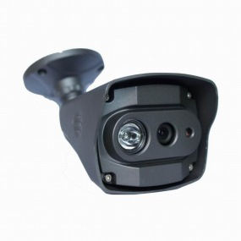
Array IR Weatherproof Camera
BA-W8096G
Main features:
Array IR Weatherproof Camera with SONY ICX663AK + Effio-V (4141), 3.6mm Board Lens 1 pcs* Array IR-LED
Feature: IR Range: 25M
1 pcs* Array IR-LED
Camera solution: SONY ICX663AK + Effio-V (4141)
Resolution: Color 1/3" SONY 960H CCD 720TVL, OSD, DEFOG, Real WDR, 3DNR, Sense-up
Perfect Night Vision
Built-In 3.6mm Board Lens
(6mm is optional)
OSD menu optional
Double glasses, no fog, no IR disturb
Cable built-in bracket suitable for wall and ceiling installation
Water Resistant Rate: IP66 Weight: 0.65Kg

Model | BA-8065G |  | BA-8070G | BA-W8096G
Sensor + DSP | SONY ICX811AK  + Effio-E (4140) |  | SONY ICX673AK  + Effio-E(4140) | SONY ICX663AK  + Effio-V (4141)
Pixel | PAL:976(H)*582(v)  NTSC:976(H)*492(v) |  | PAL:976(H)*582(v)  NTSC:976(H)*492(v) | PAL:976(H)*582(v)  NTSC:976(H)*492(v)
TV Lines | 7OOTVL |  | 720TVL | 720TVL
Signal System | PAL/NTSC
Lens Optional | 3.6mm,6mm Lens optional
Minimum Illumination | 0 Lux (Infrared on)
S/N | >52dB
Shutter speed | 1/50(1/60)_1/100,000(Sec.)
Gamma Correction | > 0.45
Synchronous mode | internal synchronization
White Balance | Auto white balance
Video Output | 1Vp-p,75ohm,BNC
Power | DC12V,1000mA
Infrared wavelength | 850nm
Infrared distance | 25M
Infrared Led | 1 pcs* Array IR-LED
weight | 0.65Kg
Temperature | (-20°C ~ +50)
Water resistance | IP66

12.
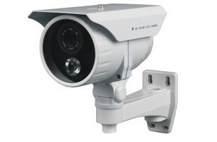
Dot matrix waterproof camera
BA-809D BA-808D BA-8052D BA-8060D BA-8070D
Main features:
◆SONY Super HAD CCD
◆2pcs 3rd generation dot matrix IR LED
◆IR range:35-50M
◆Anti-Exposure IR night vision
◆stadard 8mm lens, 4mm/6mm/16mm lens optional
◆Dual glasses, no fog, no IR disturb
◆Aluminum alloy with good heat dissipation
◆Cable pass through bracket design
Model | BA-809D | BA-808D |  | BA-8052D | BA-8060D | BA-8070D
Image Sensor | 1/3″CMOS | 1/3"SONY HAD CCD |  | 1/3"SONY HAD CCD | 1/3"SONY HAD CCD | 1/3"SONY HAD CCD
Pixel | PAL:752(H)x582(v)  NTSC:752(H)x492(v) | PAL:512(H)x582(v)  NTSC:512(H)x492(v) |  | PAL:752(H)x582(v)  NTSC:752(H)x492(v) | PAL:886(H)x542(v)  NTSC:886(H)x502(v) | PAL:976(H)x582(v)  NTSC:976(H)x492(v)
Horizontal resolution | 600TVL | 450TVL |  | 540TVL | 600TVL | 700TVL
Signal System | PAL/NTSC
Lens Optional | 4mm，6mm,8mm,12mm,16mm lens
Minimum Illumination | 0 Lux (Infrared on)
S/N | >48dB
Shutter speed | 1/50(1/60)—1/100,000(Sec.)
Gamma Correction | ＞0.45
Synchronous mode | internal synchronization
White Balance | Auto white balance
Video Output | 1Vp-p,75ohm,BNC
Power | DC12V,1000mA
Infrared wavelength | 850nm
Infrared distance | 35-50m
Infrared Led | 2pcs dot-matrix IR led
weight | 1.0kg
Temperature | -20℃ ~ +50

13.
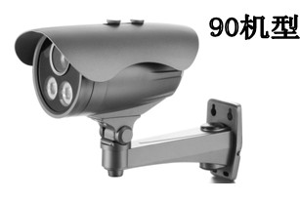
Dot matrix waterproof camera
BA-809C BA-808C BA-8052C BA-8060C BA-8070C
Main features:
◆SONY Super HAD CCD
◆2pcs 3rd generation dot matrix IR LED
◆IR range:45-60M
◆Anti-Exposure IR night vision
◆Aluminum alloy with good heat dissipation
◆8mm/F1.2 lens, 4mm/12mm/16mm lens optional
◆Dual glasses, no fog, no IR disturb
◆Waterproof grade IP66
Model | BA-809C | BA-808C |  | BA-8052C | BA-8060C | BA-8070C
Image Sensor | 1/3″CMOS | 1/3"SONY HAD CCD |  | 1/3"SONY HAD CCD | 1/3"SONY HAD CCD | 1/3"SONY HAD CCD
Pixel | PAL:752(H)x582(v)  NTSC:752(H)x492(v) | PAL:512(H)x582(v)  NTSC:512(H)x492(v) |  | PAL:752(H)x582(v)  NTSC:752(H)x492(v) | PAL:886(H)x542(v)  NTSC:886(H)x502(v) | PAL:976(H)x582(v)  NTSC:976(H)x492(v)
Horizontal resolution | 600TVL | 450TVL |  | 540TVL | 600TVL | 700TVL
Signal System | PAL/NTSC
Lens Optional | 4mm，6mm,8mm,12mm,16mm lens
Minimum Illumination | 0 Lux (Infrared on)
S/N | >48dB
Shutter speed | 1/50(1/60)—1/100,000(Sec.)
Gamma Correction | ＞0.45
Synchronous mode | internal synchronization
White Balance | Auto white balance
Video Output | 1Vp-p,75ohm,BNC
Power | DC12V,1000mA
Infrared wavelength | 850nm
Infrared distance | 45-60m
Infrared Led | The third generation of lattice lights
weight | 1.0kg
Temperature | -20℃ ~ +50

14.
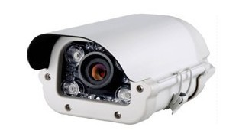
Dot matrix waterproof camera
BA-809F BA-808F BA-8052F BA-8060F BA-8070F
Main features:
◆IR range:45-60M
◆4pcs 3rd generation high power LED array
◆16mm/F1.2 lens, 6mm/8mm lens optional
◆Dual glasses, no fog, no IR disturb
Model | BA-809F | BA-808F |  | BA-8052F | BA-8060F | BA-8070F
Image Sensor | 1/3″CMOS | 1/3"SONY HAD CCD |  | 1/3"SONY HAD CCD | 1/3"SONY HAD CCD | 1/3"SONY HAD CCD
Pixel | PAL:752(H)x582(v)  NTSC:752(H)x492(v) | PAL:512(H)x582(v)  NTSC:512(H)x492(v) |  | PAL:752(H)x582(v)  NTSC:752(H)x492(v) | PAL:886(H)x542(v)  NTSC:886(H)x502(v) | PAL:976(H)x582(v)  NTSC:976(H)x492(v)
Horizontal resolution | 600TVL | 450TVL |  | 540TVL | 600TVL | 700TVL
Signal System | PAL/NTSC
Lens Optional | 4mm，6mm,8mm,12mm,16mm lens
Minimum Illumination | 0 Lux (Infrared on)
S/N | >48dB
Shutter speed | 1/50(1/60)—1/100,000(Sec.)
Gamma Correction | ＞0.45
Synchronous mode | internal synchronization
White Balance | Auto white balance
Video Output | 1Vp-p,75ohm,BNC
Power | DC12V,1000mA
Infrared wavelength | 850nm
Infrared distance | 45-60m
Infrared Led | 4pcs The third generation of lattice lights
weight | 1.0kg
Temperature | -20℃ ~ +50

15.
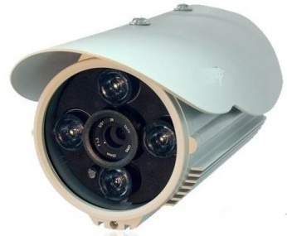
Dot matrix waterproof camera
BA-809B BA-808B BA-8052B BA-8060B BA-8070B
Main features:
◆IR range:45-60M
◆4pcs 3rd generation high power LED array
◆8mm/F1.2 lens, 4mm/6mm/16mm lens optional
◆Dual glasses, no fog, no IR disturb
Model | BA-809B | BA-808B |  | BA-8052B | BA-8060B | BA-8070B
Image Sensor | 1/3″CMOS | 1/3"SONY HAD CCD |  | 1/3"SONY HAD CCD | 1/3"SONY HAD CCD | 1/3"SONY HAD CCD
Pixel | PAL:752(H)x582(v)  NTSC:752(H)x492(v) | PAL:512(H)x582(v)  NTSC:512(H)x492(v) |  | PAL:752(H)x582(v)  NTSC:752(H)x492(v) | PAL:886(H)x542(v)  NTSC:886(H)x502(v) | PAL:976(H)x582(v)  NTSC:976(H)x492(v)
Horizontal resolution | 600TVL | 450TVL |  | 540TVL | 600TVL | 700TVL
Signal System | PAL/NTSC
Lens Optional | 4mm，6mm,8mm,12mm,16mm lens
Minimum Illumination | 0 Lux (Infrared on)
S/N | >48dB
Shutter speed | 1/50(1/60)—1/100,000(Sec.)
Gamma Correction | ＞0.45
Synchronous mode | internal synchronization
White Balance | Auto white balance
Video Output | 1Vp-p,75ohm,BNC
Power | DC12V,1000mA
Infrared wavelength | 850nm
Infrared distance | 45-60m
Infrared Led | 4pcs The third generation of lattice lights
weight | 1.0kg
Temperature | -20℃ ~ +50

16.
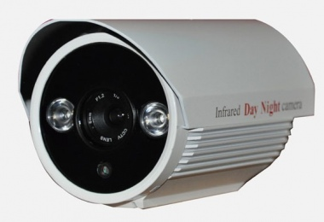
Dot matrix waterproof camera
BA-809A BA-808A BA-8052A BA-8060A BA-8070A
Main features:
◆IR range:35-50M
◆2pcs 3rd generation high power LED array
◆8mm/F1.2 lens, 4mm/6mm/16mm lens optional
◆Dual glasses, no fog, no IR disturb
Model | BA-809A | BA-808A |  | BA-8052A | BA-8060A | BA-8070A
Image Sensor | 1/3″CMOS | 1/3"SONY HAD CCD |  | 1/3"SONY HAD CCD | 1/3"SONY HAD CCD | 1/3"SONY HAD CCD
Pixel | PAL:752(H)x582(v)  NTSC:752(H)x492(v) | PAL:512(H)x582(v)  NTSC:512(H)x492(v) |  | PAL:752(H)x582(v)  NTSC:752(H)x492(v) | PAL:886(H)x542(v)  NTSC:886(H)x502(v) | PAL:976(H)x582(v)  NTSC:976(H)x492(v)
Horizontal resolution | 600TVL | 450TVL |  | 540TVL | 600TVL | 700TVL
Signal System | PAL/NTSC
Lens Optional | 4mm，6mm,8mm,12mm,16mm lens
Minimum Illumination | 0 Lux (Infrared on)
S/N | >48dB
Shutter speed | 1/50(1/60)—1/100,000(Sec.)
Gamma Correction | ＞0.45
Synchronous mode | internal synchronization
White Balance | Auto wight balance
Video Output | 1Vp-p,75ohm,BNC
Power | DC12V,1000mA
Infrared wavelength | 850nm
Infrared distance | 40-50m
Infrared Led | 2pcs The third generation of lattice lights
weight | 1.0kg
Temperature | -20℃ ~ +50

